PRACTICE OF C PROGRAMMING

1. CODE:

#include <stdio.h>

int main()

{

int three = 3, four = 4, five = 5;

int result = (three * four) / four * four + five;

printf("i know the answer of the equation :(%d * %d) / %d * %d + %d", three, four, four, four, five);

printf(" and the answer is :%d ",result);

}

OUTPUT: i know the answer of the equation :(3 * 4) / 4 * 4 + 5 and the answer is :17

1. CODE: to know the size pragmatically (USING SIZEOF OPERATOR)

#include <stdio.h>

int main()

{

printf("%d", sizeof(int));

}

OUTPUT: 4

1. CODE: range of signed integers

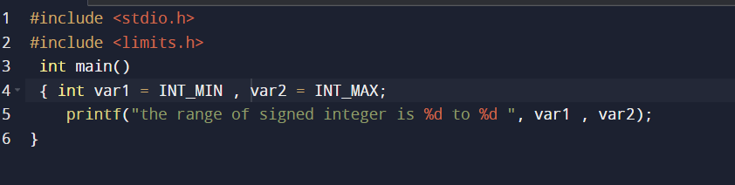

OUTPUT:



1. CODE: range of unsigned integers

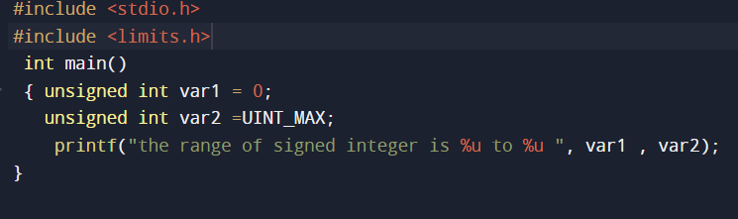

RESULT**: %u is used to print unsigned decimal value**



1. CODE: short signed value

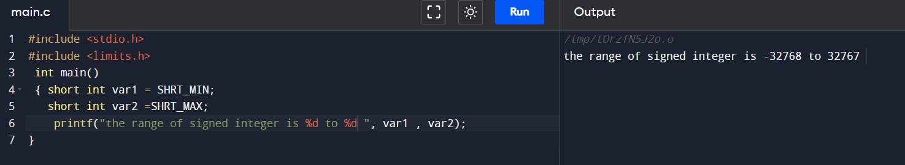

1. CODE: short unsigned value

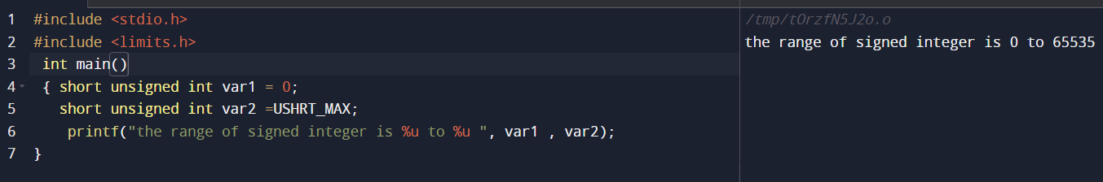

1. CODE: long unsigned value(without using l in %u)

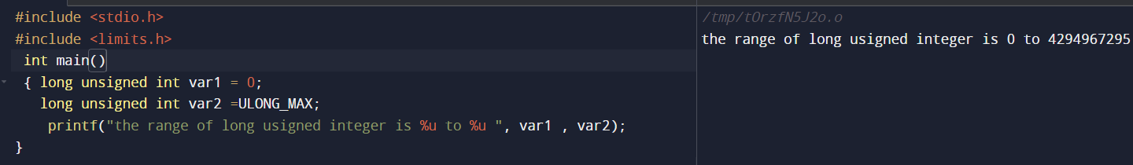

1. CODE: long signed value

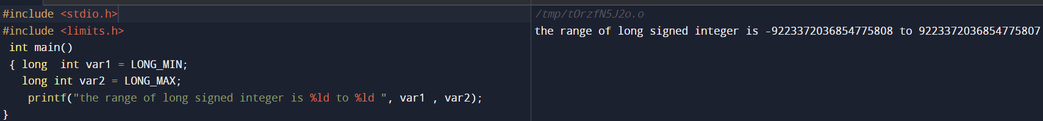

1. CODE: long unsigned value

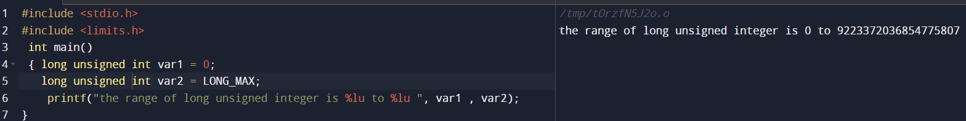

1. CODE: size of char,int and double

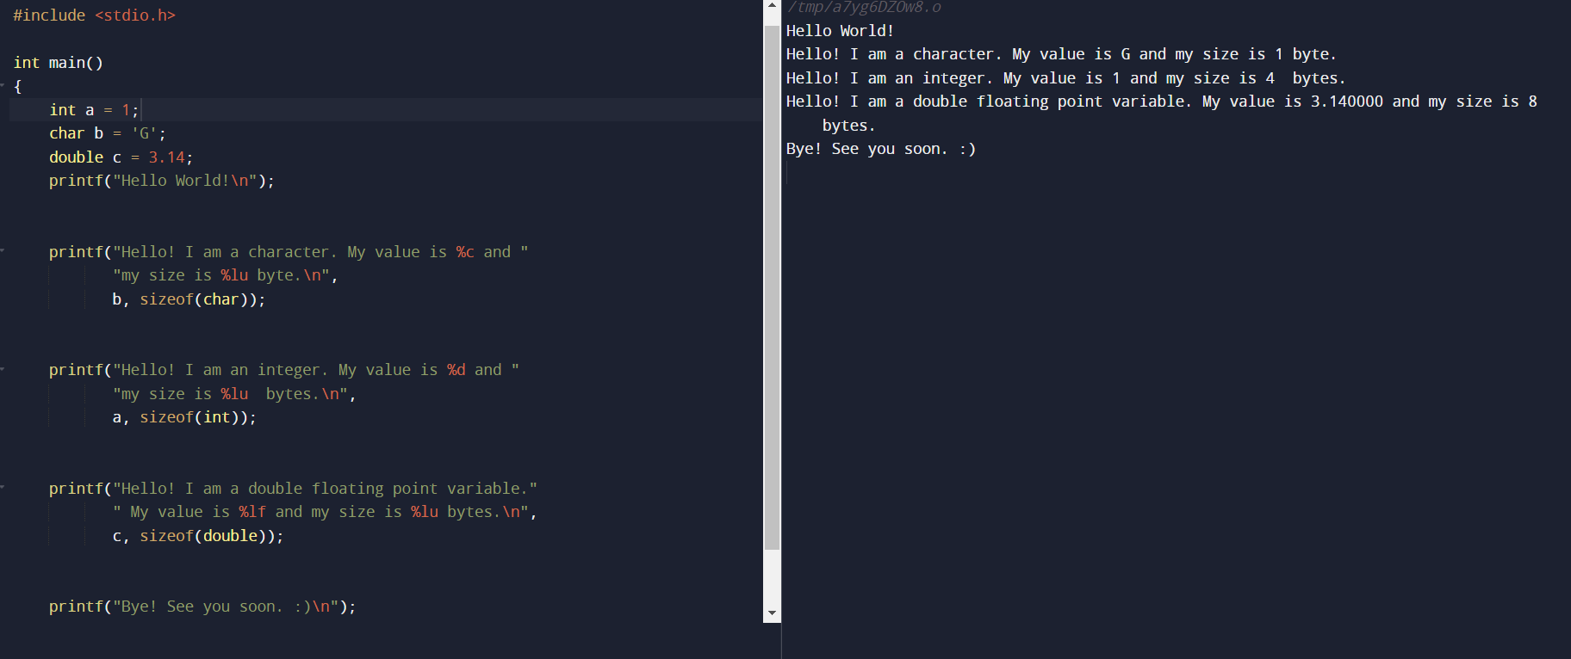

1. CODE : use of ? : operator

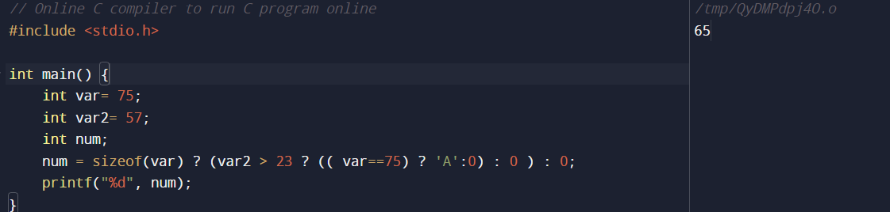

**FUNCTION WALE PROGRAMME CONVERSION FORMULA BETWEEN F AND C**

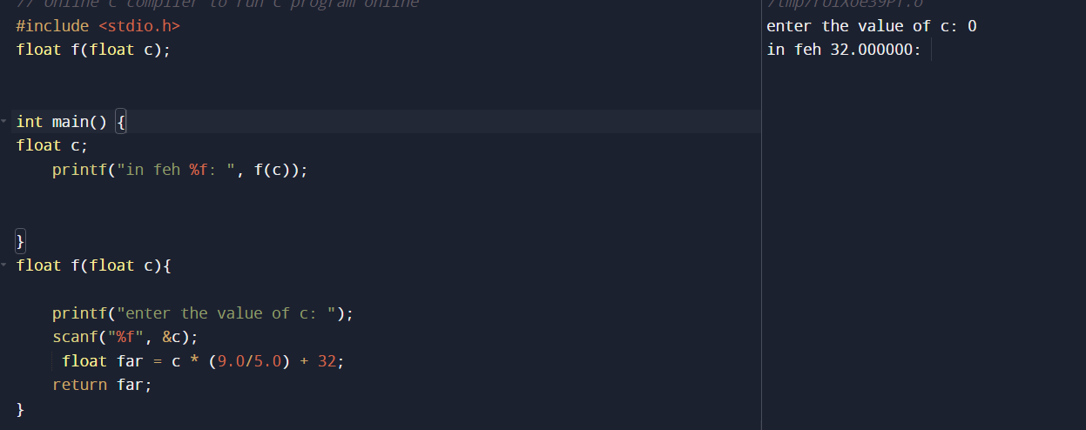

**C PROGRAMME FOR FIBO USING FOR LOOP**

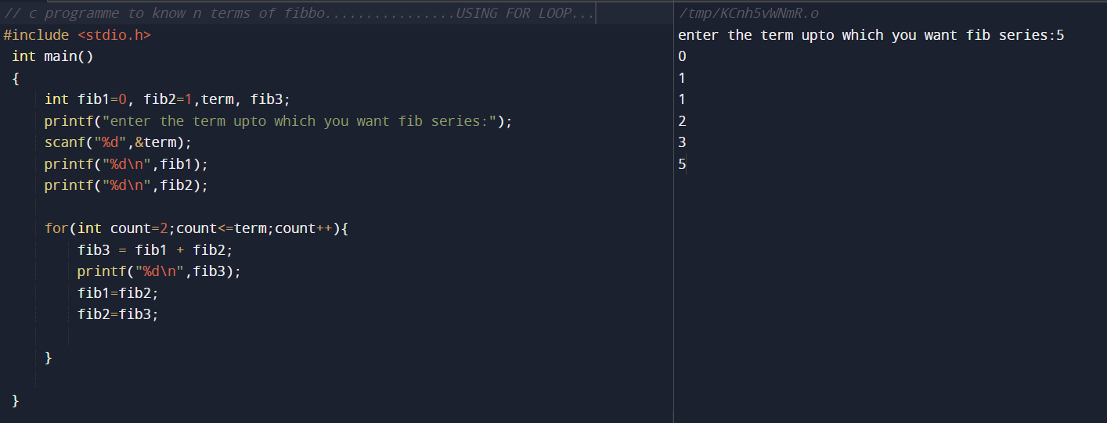

#include <stdio.h>

int main()

{

int fib1=0, fib2=1,term, fib3;

printf("enter the term upto which you want fib series:");

scanf("%d",&term);

printf("%d\n",fib1);

printf("%d\n",fib2);

for(int count=2;count<=term;count++){

fib3 = fib1 + fib2;

printf("%d\n",fib3);

fib1=fib2;

fib2=fib3;

}

}